**EXPLORATORY DATA ANALYSIS ON AIRBNB BOOKINGS**

**By**

**Pooja Hoolageri**

**ABSTRACT**

This study examined the relationship between various parameters of the AIRBNB dataset such as host id, hostname, neighbourhood group, neighbourhood, room type, price number of reviews, availability. An exploratory data analysis using field data points collected from the Airbnb listings in the metropolitan area of New York city reveals intriguing findings. The analysis helps us in understanding the most preferred hosts and neighbourhood groups by guests, the density of properties across the various neighbourhood, the number of room types belonging to each neighbourhood group, expensive neighbourhood groups, busiest hosts, preference of room types by guests, price of various room types. This analysis helps draw insights from the data and can be utilised for security, business decisions, understanding of customers and providers, behaviour and performance on the platform, guiding marketing initiatives, implementation of innovative additional services and much more.

**1. INTRODUCTION**

Airbnb, Inc. is an American company that operates an online marketplace for lodging, primarily homestays for vacation rentals, and tourism activities. Based in San Francisco, California, the platform is accessible via the website and mobile app. Source; Wikipedia

Airbnb mostly has a business in properties on rentals. Airbnb does not own any property instead works as an intermediator between property owners and customers looking for properties for rent.

This booking of room process can be done from the website or app of Airbnb. Airbnb receives bookings from all over the world so they have to work on building a relationship

with the property owners which they wish to put on rent for the visitors.

What we have done is that we had analysed some major areas based on the given dataset for NYC

To help Airbnb with the decision to an expansion of business in particular areas.

**There are a few attributes of the AIRBNB bookings given below**:

1. ID**:** There is a unique ID number for every entry in the dataset, with this unique ID information from the data can be easily extracted and identified
2. NAME**:** Every neighbourhood group has different hotels or renting rooms owned by the host which is termed as a name in the data frame.
3. HOST ID**:**

SameHosts may have properties in different neighbourhood groups so a

unique ID for the host is given as Host ID.

1. HOSTNAME**:**

Hosts who have listed their properties on Airbnb have a name which is termed the Hostname in the data frame

1. NEIGHBOURHOOD GROUP**:**

The name of groups of different hosts who have listed their property on Airbnb is termed a neighbourhood group.

1. NEIGHBOURHOOD**:**

Different localities of New York City are known as a neighbourhood in the data frame.

1. LATITUDE & LONGITUDE:

Latitude and longitude can be utilized to identify specific locations, which can also help identify landmarks.

1. ROOM TYPE:

Different types of rooms are available which are categorized as a private room, entire home/apartment, shared room

1. PRICE**:**

Every property listed on Airbnb has a rental price for owing over some time.

1. MINIMUM NIGHTS**:**

This data gives us information about the period of stay by guests in the hotels or renting houses

1. NUMBER OF REVIEWS**:**

Contains information on the Count of reviews given by particular guests staying at rooms

1. REVIEWS PER MONTH**:**

The count of reviews per month by every guest is stored in this column.

1. CALCULATED HOST LISTING COUNT:

Every host owns different properties across different neighbourhood groups and the count of this property of every host is listed.

1. AVAILABILITY 365:

This data helps us in knowing the number of days the hotel or renting a place is available in a financial year.

1. **PROBLEM STATEMENT**

* EDA - Exploratory data analysis (EDA) is used to analyze and investigate data sets and summarize their main characteristics, often employing data visualization methods. (Wikipedia)
* Since 2008, guests and hosts have used Airbnb to expand on travelling possibilities and present a more unique, personalized way of experiencing the world.
* Data analysis on millions of listings provided through Airbnb is a crucial factor for the company.
* These millions of listings generate a lot of data - data that can be analyzed and used for security, business decision, guiding marketing initiatives, implementation of innovative additional services and much more.and is a mixture between a paragraph and numerical values.

This dataset has a few problems in it such as

* Rentals/properties present in Neighborhood group, Neighborhood, Room type
* Overall contributions of each neighborhood in the count of listings throughout NYC
* Total count of room types available in NYC
* Average price for each neighborhood group
* Average Price for each neighborhood areas in respective neighborhood groups
* Price distribution data in every neighborhood-group
* Overall, Price distribution through NY
* In search of a famous Host
* Number of reviews for each neighborhood-group
* Average price for room-type throughout NY

1. **STEPS INVOLVED**

**a.** Python Library:

**NumPy:** NumPy is a library for the Python programming language, adding support for large, multi-dimensional arrays and matrices, along with a large collection of high-level mathematical functions to operate on these arrays.

**Pandas:** panda is an open-source library that provides high-performance data manipulation in Python.

**Mat plot:** Matplotlib is a python library used to create 2D graphs and plots.

**Seaborn:** Seaborn is a library for making statistical graphics in Python.

**Word Cloud:** Word Cloud is a data visualization technique used for representing text data in which the size of each word indicates its frequency or importance.

1. **To Import Data frame:**

Data frame has been imported from google drive and reads data frame applying read_csv.

1. **Recognize the Data Frame:**

Dealing with a huge data set is a time-consuming part. To minimize the workload and efforts we must have to distribute data and analysed the contents first.

1. **Dealing with Null Values:**

* As we have seen, our data frame contains a large number of null values so we need to deal with null values at the beginning of our project to discard null values from the data frame to improve our accuracy. firsts we have calculated the null value in each column such as **name, hostname…..** Last review column contains 10052 records with null values. This column is not much of a help to analysis. So, we drop that column.
* We then equated the null values of

‘reviews_per_month’ column as 0.

1. **Deal with Data:**

**Univariate Analysis**: - ***Univariate Analysis*** is the key to understanding every variable in the data. Learn how to visualize and interpret ***univariate*** data.

**Multivariate Analysis:**

***multivariate*** data is to make a matrix scatterplot, showing each pair of variables plotted against each other.

1. **Function & Method applied for Data**

**frame:**

Group By function: ***groupby*** () function is used to split the data into ***groups*** based on some criteria. Statistical method: To find some statistical summary like mean, max, min, count, standard deviation etc Using statistical data, we have represented the various types of graphs.

1. **Creating heat map and finding corelation between different columns with each other:**

We have created a heat map between columns to find the co-relationship between all the columns with the help of correlation of statistical method

1. **Performing Analysis:**

for finding out the most availability_365, top neighbourhood, Booking in the city, Host in the city, Different room types, Top host, Average Nights in the room, Price

distribution

finally, from all the results after performing exploratory data analysis meaningful conclusions were drawn which are included at the end of the document

1. **Data Analysis:**

Eda is performed with the data frame on various variables which are dependent on each other and visualization of the result is done using various plots such as scatter plot, boxplot, bar plot, violin plot, histogram, heatmap, word cloud, line chart, few of the important analysis is shown below.

* 1. **Density of neighbourhood across the different locations:** Latitude and longitude data is used to know the density of neighbourhood groups across the location. The data is visualized with the help of a scatter plot. Latitude and longitude form a grid system that helps to identify the exact or absolute, locations on the surface of the earth. Latitude and longitude can be utilized to identify specific locations, which can also help identify landmarks.

* 1. **Room type within different neighbourhoods:**

Datasets of different room types and neighbourhood groups are utilized for visualization which is done by grouping the data. Bar plot is taken into account for visualization.

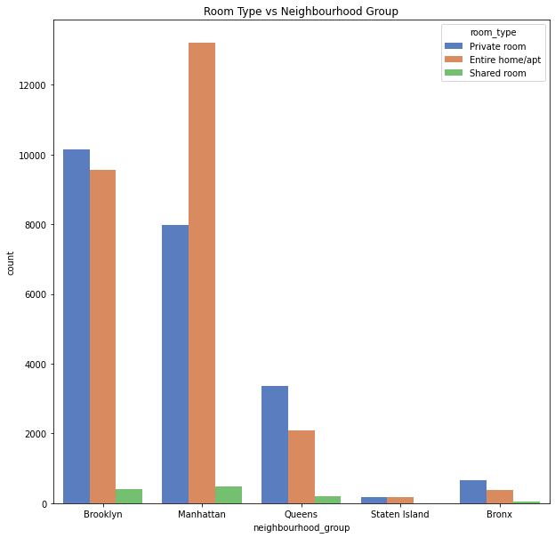

*Figure 1.1 Room types within different neighbourhoods*

The above results showed that Number of properties available in different neighborhood groups is more in Manhattan (Home room type)

**Longitude and latitude**

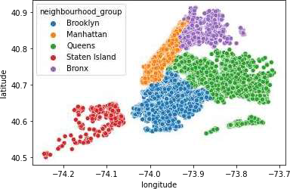

We can see the geo locations of all neighbourhood groups throughout

New York.

* 1. **Price over neighbourhood groups** Datasets of different room types and neighbourhood groups are utilized for visualization which is done by grouping

the data. Bar plot is taken into account for visualization

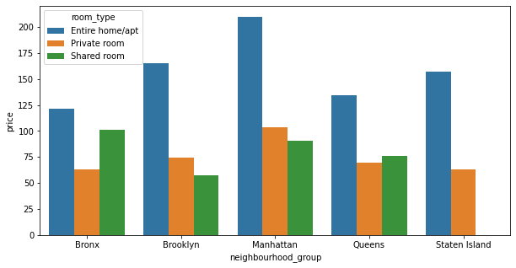

It shows that Manhattan is quite an expensive neighbourhood group compared to others.

* 1. Unique price category counts:

Price is classified into 3 groups i.e., price below 80 is classified as cheap, price between 80 and 150 is classified as affordable and price above 150 is classified as expensive, group by function on neighbourhood group along with price category is applied to get the count of neighbourhood groups based on price category. Bar plot is taken into account for visualization. It is observed that the least people prefer the expensive category, instead, the maximum people prefer the affordable category followed by the cheap category in all the neighbourhood groups except in the case of Bronx and Queens where the relationship is reversed.

**5. CONCLUSION:**

* Price depends on Neighborhood-group. Its high in Manhattan.
* Within neighborhood groups, price fluctuates between the range. But Manhattan is the place where we see a lot ups and downs in price, giving the conclusion that Manhattan is the city which contains highest price and as well as lowest price.
* We can get the famous host (Sonder from Manhattan) from the number of properties he is offering (OR) We can find the famous host (Jordan from Queens) with respect to most reviewed place as well.
* People reviewed at most in properties of Queens which has the lowest prices for their properties as well.
* Throughout NY, Entire home/apt is the room type which is mostly in demand.
* (Manhattan is the place which is famous and can be a good option for the companies to invest on properties of Entire home/Apt.

Also, I have analysed prices and reviews showing the major contribution of customers for the affordable category.

Based on the Collab study we concluded that the Manhattan and Bronx can be major business centres with Airbnb with private rooms and the price category must be medium/affordable.

So, the company must show interest in acquiring more business with such types of property owners.

References-

1. Wikipedia
2. Geeks for Geeks
3. Stack overflow